**Abstracts for GHHIN Stocktaking Papers**

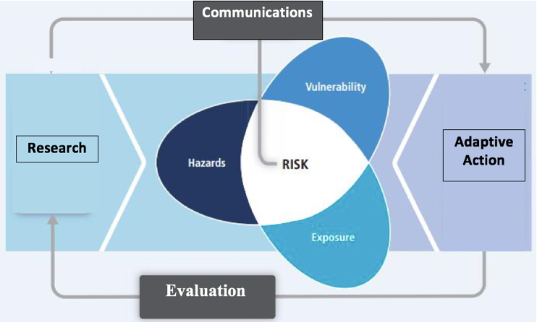

**Stocktaking Paper Objectives**

1. Take stock of current actions and information about heat-health hazards across the dimensions of risk (hazard, vulnerability, exposure, risk reduction, monitoring impacts)
2. Provide grounding for the development of the global synthesis report
3. Help organize and inform a common thread framework of domains of information and action to be followed by the GHHIN
4. Inform the basis of the country/member profiles – and provide content to begin to populate the initial web-based sharing platform

**Paper 1: Synthesis of Global Heat HAZARD + EXPOSURE**

**Page target 20-25, with annexes as required**

This stocktaking will help identify and outline the global state of the science with regards to understanding and predicting the heat related hazards to human health and human population exposure to increasing and extreme temperatures. It will highlight similarities and differences in systems for characterizing the hazards, heat prediction across timescales (weather, S2S, and decadal). This stocktaking will inform a common thread framework for GHHIN to track progress being made in key categories, synthesize current science in a standard way, and establish indicators to help structure country profiles that will be completed by GHHIN members autonomously.

**Part 1: State of global, regional, and national temperature observation and monitoring systems** of (climatological records, RCC capabilities eg: IMD Regional Forecast)

**Part 2: State of extreme ambient heat hazard characterization/research (what is the research/method used to inform how an extreme heat event is defined? Inclusion of mortality/morbidity/hospital admission data?)**

**Part 3: State of Extreme Heat Prediction**: State of the science in products, sources of predictability, by timescale: climate predictions, climate outlooks, forecasts, warnings);

**Part 4: Early Warning Systems** parameters, definitions

**Part 5: Exposure:** Geographic Determinants: Latitude, Urban Heat Islands; Social Determinants (point to vulnerability chapter)

What does good practice of hazard analysis look like to inform a HHWS

Research

**Paper 2: Synthesis of Global Heat VULNERABILITY + RESPONSES:**

**Page target 20-25, with annexes as required**

This stocktaking paper will help identify and outline the global state of the science with regards to understanding human vulnerability to heat exposures, and the broad range of responses and actions which can be taken to reduce human exposures and impacts. It will describe categories of vulnerable populations; highlight similarities and differences in response opportunities and systems, from behavioral to infrastructural, and legal actions which can be taken over different timeframes. Intervention effectiveness will be cited as available. This stocktaking will inform a common thread framework for GHHIN to track progress being made in key categories, synthesize current action and science in a standard way, and establish indicators to help structure country profiles that will be completed by GHHIN members autonomously.

**Technical stocktaking paper on strategies and measures for extreme heat preparedness and adaptation across timescales**

**Part 1: Population Vulnerabilities**: This section will outline diverse population groups whom are vulnerable to exposure to ambient heat conditions, and represent target populations for protection. It should describe geographic, social, and physiological sensitivities. It should highlight target decision makers who have the ability to take protective actions for these high risk groups (table). E.g. Workers: Business Owners; Psychotropic pharmaceutical patients: Pharmacists/Physicians; Elderly: Families/Social Services.

**Part 2: Responses**

1. **Planning and Governance**: Heat Health Action Plans, legal classification of heat as national emergencies
2. **Institutional Capacity & Partnerships**: Common institutional partners engaged to define and respond to needs. (e.g. who should be/ is involved in forecasting, preparing and responding to the hazard)
3. **Engagement and Communication Strategies:** What communication strategies are used and most effective both during an event and for long lead time planning.
4. **Training and Capacity:** what kinds of training and capacity is needed to better understand and respond to heat health risks
5. **Exposure and vulnerability reducing interventions**
6. Individual
7. Community
8. Work Place
9. Health Facility
10. Policy/Legislative/Regulation
11. Social Services
12. **Monitoring and Evaluation** of intervention effectiveness, information sufficiency (e.g. vulnerability id, warning accuracy), and impacts (e.g surveillance)

|  |  |  |  |
| --- | --- | --- | --- |
| **RESEARCH + INFORMATION** | **IDENTIFIED RISK** | **RESPONSES** | **Detailed Subcategories** |
| **XXX** | **HAZARD** | **MONITORING, OBSERVATIONS, FORECASTING** | **OBS AND MONITORING: Heat Parameters & Health Outcomes**  What heat parameters (tmax, tmin, heat index, etc) are most important for which specific population and in what geographic conditions**?** |
| **FORECASTING: Data and Forecast Products**  What data and forecast products, indicators, and monitoring is needed (at what spatial and temporal resolution & lead time) and what is currently being used by health professionals to make decisions |
| **Climate change mitigation** |
|  | | | |
| **XXX** | **EXPOSURE** | **ADAPTIVE ACTION** | **Governance and Planning (HHAP)** |
| **XXX** | **VULNERABILITY** | **Institutional Capacity & Partnerships** |
| **Engagement and Communication Strategies** |
| **Training and Capacity** |
| **Exposure and vulnerability reducing interventions** |
| **Impacts, Knowledge adequacy, Effectiveness** |  | **Monitoring and Evaluation** |

*[historical] [pre-event] [during event] [post-event] [long term]*

**Untitled%20spreadsheet%20-%20Sheet1.pdf**